USER MANUAL OF RETRACTABLE ROOF

CLIENT: - TRANSFOEMER & RECTIFIERS INDIA LTD.
MFG. YEAR.: 2024-25

DESIGNED, DEVELOPED & MARKETED
BY

G-BLOCK, 1ST FLOOR, THERMAX CHOWK
MIDC, ABOVE RENAULT SHOWROOM
CHINCHWAD, PUNE-411019

TEL.NO. - +912066304033
EMAIL:-info@nihva.com
www.nihva.com
AUTOMATIC RETRACTABLE ROOF
SIZE | : W 3003mmX L 3200mm
NO OF PANEL | : 12 Nos
SR NO | -
CLIENT | : Transformer & Rectifiers (India) Ltd.

CONTENTS

- Introduction

- Principle

- Roof General Information

- Dispatch & Unloading

- Ordering Of Spares

- Installation STEP

- USP

- Pre-Operating Instruction

- Cleaning Instruction

- General Arrangement Drawing

- Routine maintenance & Lubrication

- Spare Part List

- Roof Operational procedure ( Open / Close Position )

- Auto / Manual Operation

- Warning

- Roof Cleaning

Introduction:
Established in 2012 in Pune (Maharashtra, India). We are the leading solution Provider for Residential and commercial buildings as well as Industries.
SHIVAAH is a prominent brand of NIHVA Technology Pvt. Ltd.
At “SHIVAAH,” we specialize in offering comprehensive solutions for Residential and commercial buildings. Our involvement in any project begins with a throughout understanding of the requirements, functionality, and design.
Leading to the development of a customized solution, followed by expert installation and commissioning.
We are committed to providing ongoing service support that goes beyond our initial contractual obligations.

Principle:
Retractable Roof systems is designed for homes, bungalows, villas, apartments, swim centers, hotels, restaurants, hospitals, shopping malls, offices, and warehouses. This design adds luxury by allowing partial sunlight when entering the site during the day and a view of the sky at night. Retractable Roof can be operated in a variety of ways, including folding roof, sliding roof, telescopic roof, one-dimensional, two-dimensional, vertical lift and horizontal lift.

- Roof General Information:
Retractable roof modules in existing constructions consist of 1,2,…..5 roof panels driven by one drive unit. Usually, the Class II mechanisms used are in the form of a four-bar linkage, whose task is to absorb sudden surges in wind. The pre-set objective sought new solutions that would allow the implementation of roof modules with an increased number of panels, for example, three or more. The movement of the mechanisms is strictly defined
Motorized retractable roofing systems encompass a motor that is used to retract or expand the roof at the push of a button and is operated by a remote control or a wall switch. Due to their convenience and ease of use, motorized systems in retractable roofs for terraces have raised the bar. The comprises various elements that support its functioning, including:
● Frame structure
● Roofing Material
● Motorized Mechanism
● Tracks and Guides
● Sensors
● Safety Features
The motorized system gets activated when operated through a switch or remote. Once activated, the motorized mechanism moves the front fabric of the motorized retractable roofing for homes, which pushes the fabric out when the system is deployed and backward when it is retracted.

Dispatch & Unloading:

1. Loading, for dispatch, will be our responsibility. On receipt of the Retractable roof material at site, please check and ensure that there is no physical damage to the equipment.
2. While unloading the equipment from the transporting vehicle, please ensure to use slings with rated capacity higher than the gross weight of the Stationary lift in packed condition.
3. Slings MUST be hooked ONLY at specified positions. These positions are indicated and marked with a figure of ‘HOOK’. Improper sling position or improper slinging could cause damage to the equipment.

Ordering Of Spares:

When ordering for spare, please specify the following in your Purchase Order.
- Equipment Name
- Model Number
- Equipment Serial No.
- Part name / Description
- Part Number
- Quantity required
- Delivery period / time
- Mode of dispatch

This would avoid ambiguity and help us serve you better.

Installation STEP

- Assemble main sections
- Install Floor Track
- Install main sections
- Install side sections
- Install accessories
- Sealing treatment.

USP of Retractable Roof:

- Specially extruded non-corrosive Aluminum Profile.

- Imported Polycarbonate sheet.

- UV-A & UV-B ray protection.

- Italian/ German make motor with remote control.

- High heat resistant EPDM gasket to make the system leak-proof.

- Stainless steel parts & fasteners.

- LED light system can be provided as per requirement.

- RAL Powder coating finish as per requirement.

- No need of any licence from municipal authorities for terrace roofing’s since it is completely retractable.

- Operation:
Remote
Push button
Manual.

Pre-Operating Instructions:

- Ensure Electrical supply
- Ensure Motor connection and proper earthing.
- Ensure percentage of charging of cell of Remote.
- Ensure Fuse of Remote
- Ensure joint leakage.
- Ensure proper location of Retractable Roof
- Ensure Auto/Manual mode of Retractable Roof
- Ensure Interlocking of Panel

Cleaning Instructions:

- First Spray water on Retractable Roof.
- Clean the Retractable Roof with Micro Fabric cotton to avoid scratches on profile and sheet.
- At time of cleaning of Retractable Roof hang safety belt.
- Avoid walking on sheet. You can walk on support member instead of sheet.

General Arrangement Drawing:

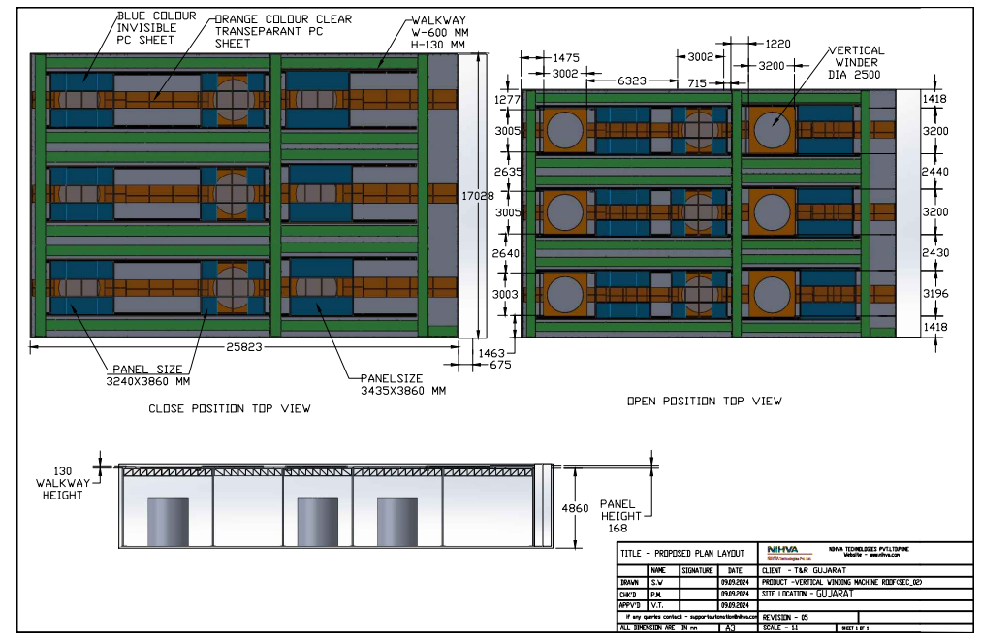
VMC UNIT
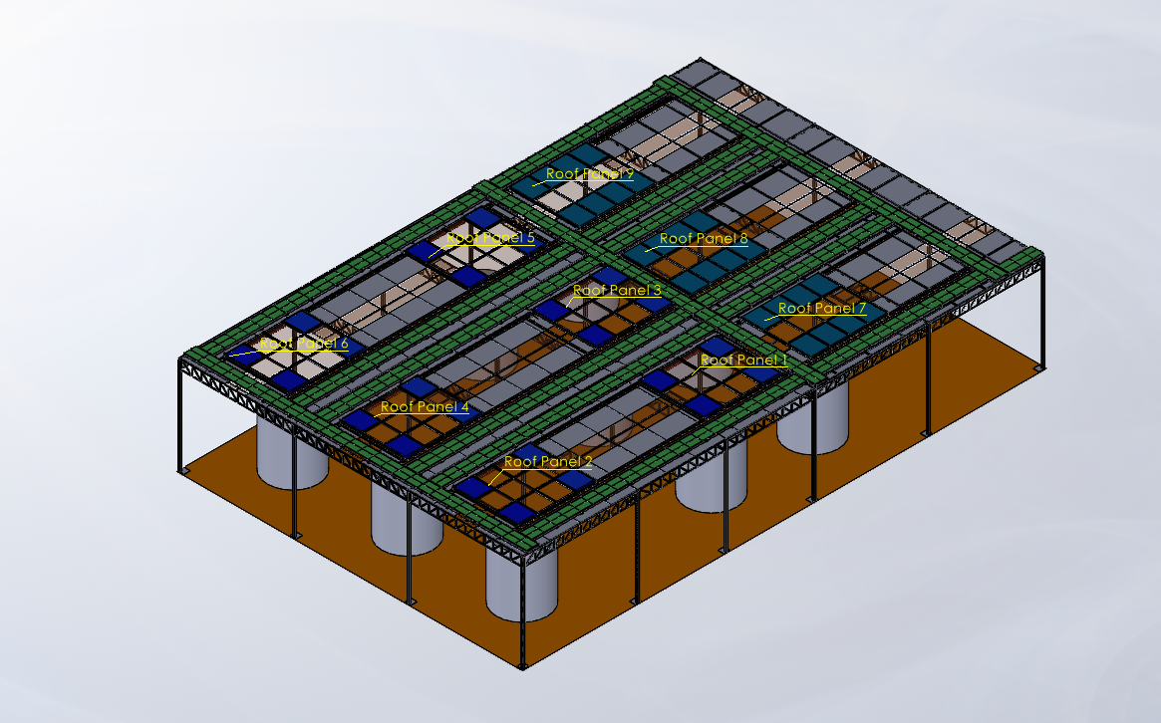
Roof Closed Position

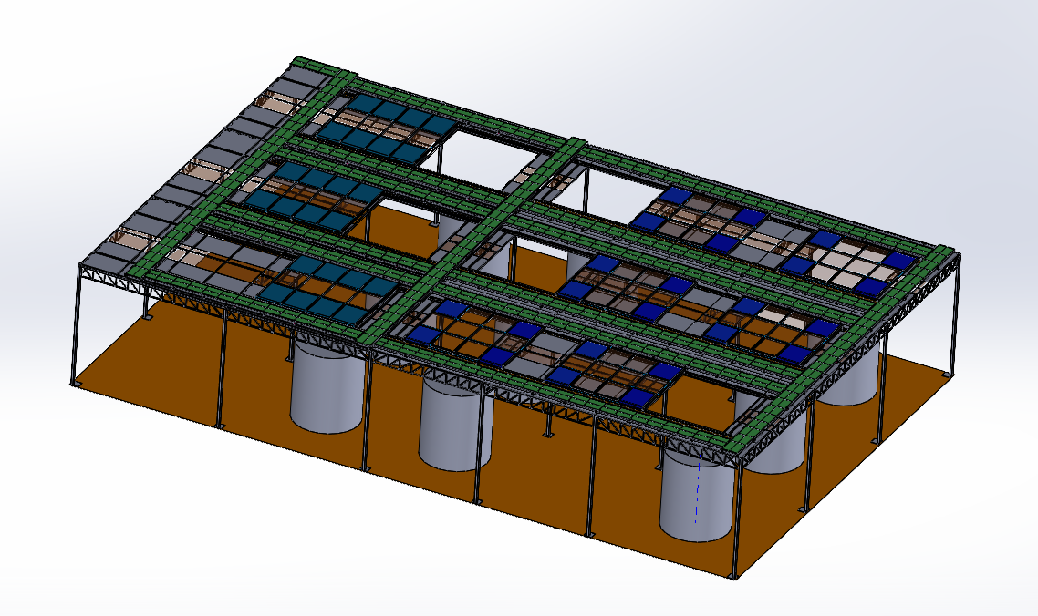
Roof Open Position

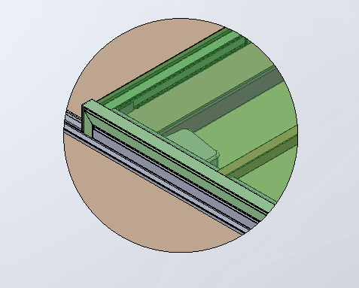
Motor Mounting Position

K) Routine Maintenance & Lubrication:

These recommendations are applicable to the Retractable Roof considering average daily usage of 05 to 10 times. If it is used more frequently, the same time intervals for the maintenance should be adjusted accordingly.

DAILY:
- Check Motor Auto/Manual mode for smooth operation.
- Check electrical connections for their proper working.

MONTHLY:
- Grease the rack and Pinion.
- Check Tightening of Bolt
- Check the Fuse of Remote
- Check the cell charging of Remote
- In case of Push Button, check the wire connection of switches.
- Check the alignment of Roof.

Don’ts:

1.Incorrect or improper use of this product can cause damage to persons, animals, or properties.
2.Please ensure that the input voltage used matches with the supply voltage of gate opener
(AC220V±10% 50Hz).
3.More than 3 to 4 persons never allow to stand on Retractable L-Shape Encloser panel.
4.All modifications to wiring or electrics, and any adjustment or maintenance to 240VAC MUST be done by a qualified electrician.
5.Guide Roller wheels should rotate easily and be free from dirt / grime.
Make sure that Retractable Roof end stopper is each end (Both End) of the track to prevent the panel travelling off the track.
6.Never allow anyone to Stand on the Retractable Roof while moving. Avoid walking on sheet.
7.Keep remote control and other control devices (Push Button) out of children’s reach, in order to avoid unintentional activation.
8.Ensure power plug is disconnected from the power socket during cleaning or maintenance.

Spare Part List:

Sr no | Serial Number | Details | Image
1 | 20021245 | NYLON WHEEL | 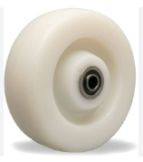
2 | 20021246 | Remote Cell | 
3 | 20021247 | Motor Fuse | 
4 | 20021248 | Push Button | 
5 | 20021249 | Rack | 
6 | 20021250 | Pinion | 
7 | 20021251 | SS Hardware | 
8 | 20021252 | Interlocking Nylon Pad | 
9 | 20021253 | Limit Switch | 
10 | 20021254 | Motor Key | 
11 | 20021255 | EPDM Rubber | 
12 | 20021256 | JOINING PLATES | 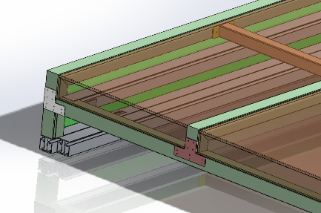
13 | 20021257 | SS RIVET | 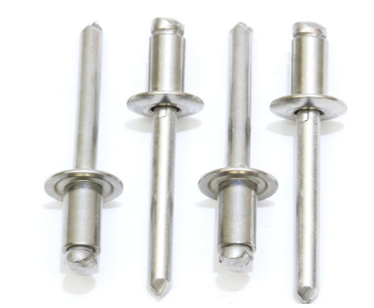

- Roof Operational procedure (Open / Close Position)
The motorized system gets activated when operated through a switch or remote. Once activated, the motorized mechanism moves the front fabric of the motorized retractable roofing for homes, which pushes the fabric out when the system is deployed and backward when it is retracted.

- On - First main power on the switch of Retractable Roof Automation Systems / Motor

- Roof open - Press open Remote control / Push button to open Retractable Roof gate, when motor is opening, the blue light will light on, once full open, motor stop by open limit, the blue light will off.



- Roof Close - Press close Remote control / Push Button to close the Retractable Roof, when motor is closing, the red light will light on, once full close, motor stop by close limit, the red light will off.

- Maximum continuous operating time (at nominal torque) 7 minutes ( The control unit limits continuous operation to the maximum value )

- Auto / Manual Operation - Manually release the gearmotor so that the gate can be opened and closed

The opener comes with an easy operating manual release. It brings the easiest manual release operation just in case of any emergency.

Insert the Release Key（provided）and turn it clockwise four turns to disengage the clutch between the gear shaft and power output. Now the opener is in manual operation.



Manual to Automation

Turn clutch anticlockwise four turns to engage the clutch between the gear shaft and power output. Lock the Release Key provided & remove it. Now the opener is in automation operation.


Guide Roller wheels should rotate easily and be free from dirt / grime.
- Warning:
Incorrect or improper use of this product can cause damage to persons, animals, or properties.

Please ensure that the input voltage used matches with the supply voltage of gate opener
(AC220V±10% 50Hz).

All modifications to wiring or electrics, and any adjustment or maintenance to 240VAC MUST be done by a qualified electrician.

Guide Roller wheels should rotate easily and be free from dirt / grime. Make sure that Retractable Roof end stopper is each end ( Both End ) of the track to prevent the roof travelling off the track.

Never allow anyone to hang onto the Retractable Roof while moving.

Keep remote control and other control devices (Push Button) out of children’s reach, in order to avoid unintentional activation.
Ensure power plug is disconnected from the power socket during cleaning or maintenance
- Roof Cleaning
You can use a soft brush or leaf blower. After removing dirt from the tracks, simply use a soft, damp cloth and a non-abrasive cleaning substance to wipe them down Make sure you clean the debris gently, so they do not scratch the polycarbonate sheets. 2. Mix Mild liquid Soap with Lukewarm Water to clean the Polycarbonate sheets– Refrain from using any harsh chemicals or strong detergents.



